MLG 381 ASSIGNMENT 2

Group members : Hrudhay Reddy Garisa (577833) , Edwin le Coitre (577328) , Joshua Meyer (577355) , Bophelo Maroga (577651)

Lecturer name : Matildah M.Chiruka

Contents

Question 1 2

Question 2 4

# Question 1

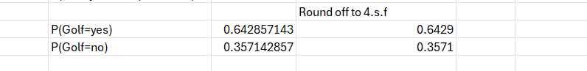

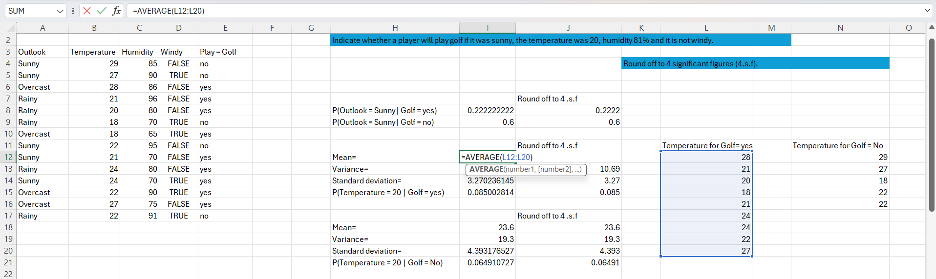

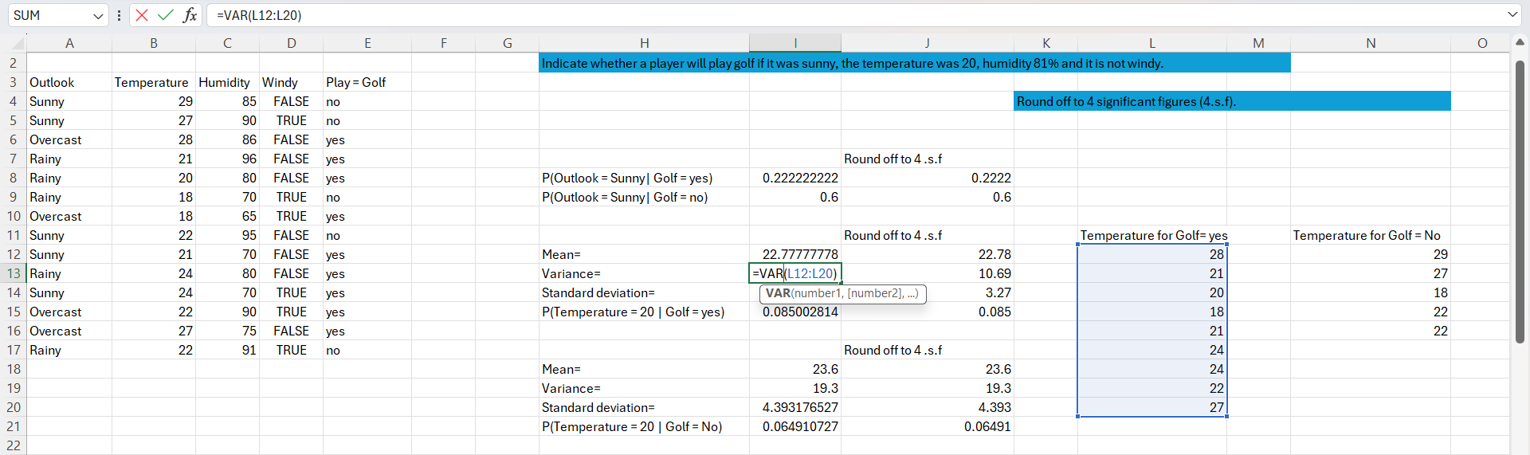

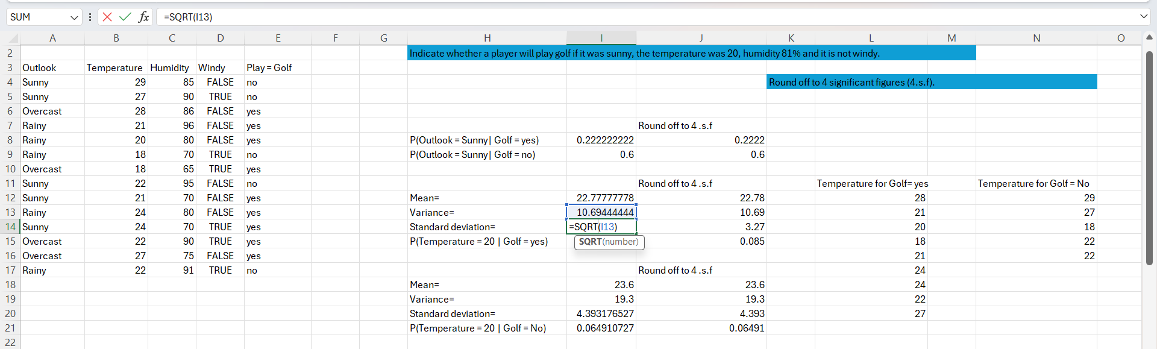

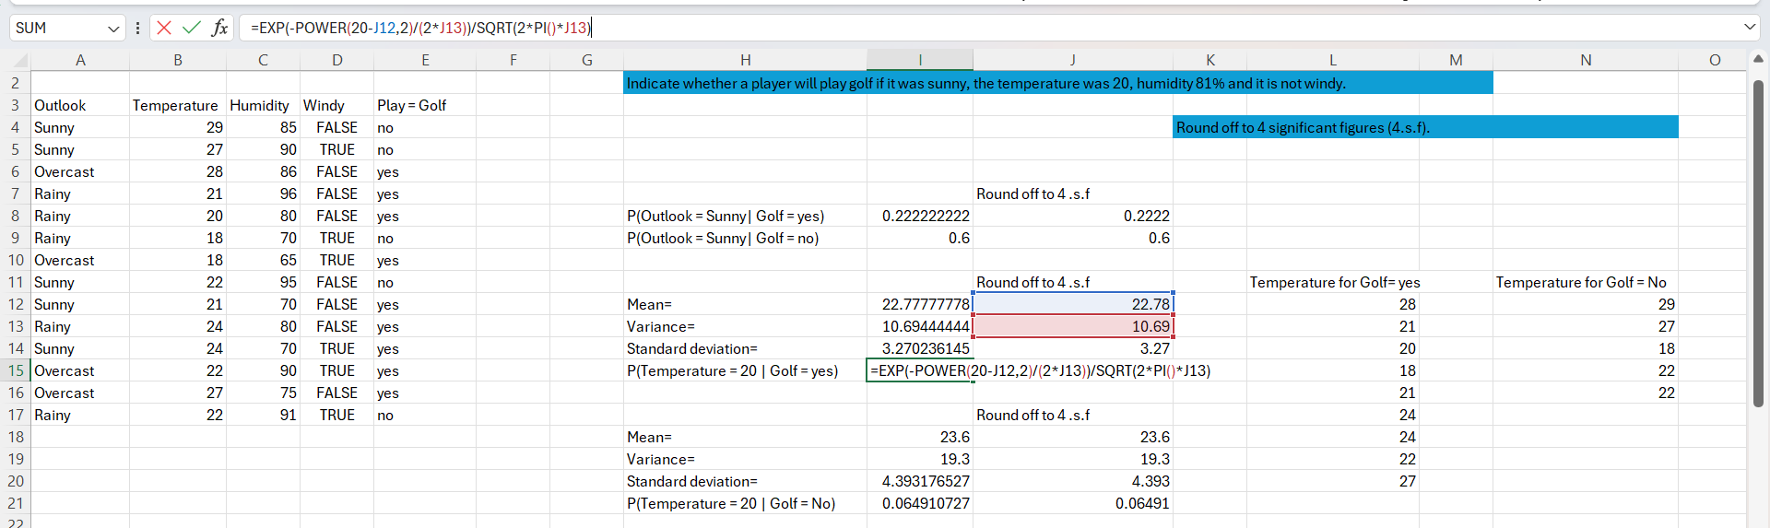

# Question 2

1. Weight Vector:

𝑤 = 𝑎 (s1 – s2)

= 𝑎 [(9;5) – (7;2)]

= 𝑎 (2;3)

= 2𝑎; 3𝑎

1. Hyperplane Equation:

Using the weight Vector Points

( ) * ( ) +w0 = 1

( ) * ( ) +w0 = -1

( ) * ( ) +w0 = 1

( ) * ( ) +w0 = -1

Solve Simultaneously

18𝑎 + 15𝑎 + w0 = 1

14𝑎 + 6𝑎 + w0 = -1

33𝑎 + w0 = 1

20𝑎 +w0 = -1

Substitute for omega

w0 = 1 - 33𝑎

20𝑎 + 1 - 33𝑎 = -1

13𝑎 = 2

𝑎 =

w0 = 1 – 33 ( )

w0 = 1 –

w0 =

Using the weight Vector Points

𝑔(𝑥⃗ ) = ( ) * ( ) +w0

𝑔(𝑥⃗ ) = ()x1 + ()x2 – ()

𝑔(𝑥⃗ ) = ()x1 + ()x2 – ()

𝑔(𝑥⃗ ) = 4x1 + 6x2 – 53

𝑔(𝑥⃗ ) = ()x1 + ()x2 – ()

𝑔(𝑥⃗ ) = 2x1 + 3x2 – 26.5

∴ 𝑔(𝑥⃗ ) = 4x1 + 6x2 – 53 or 𝑔(𝑥⃗ ) = 2x1 + 3x2 – 26.5